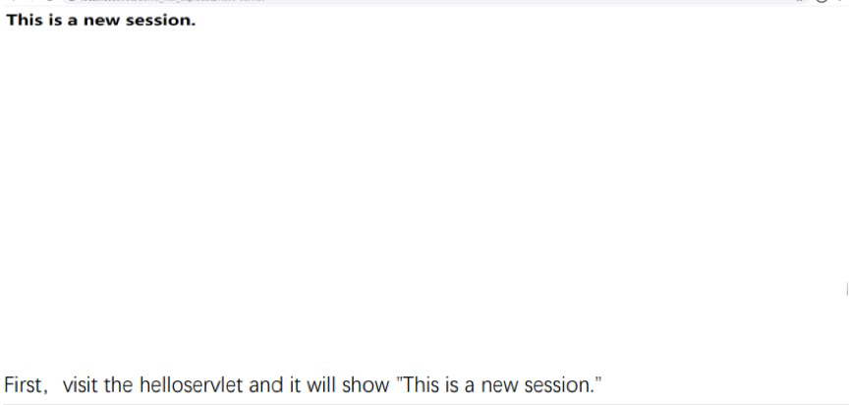

First，the helloservlet will show ”This is a new session.”

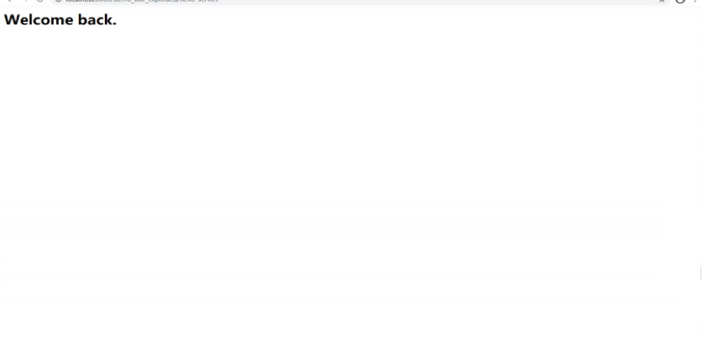

Then，we open edge settings to “cookie和网站权限”, and “管理和删除cookie和站点数据”.

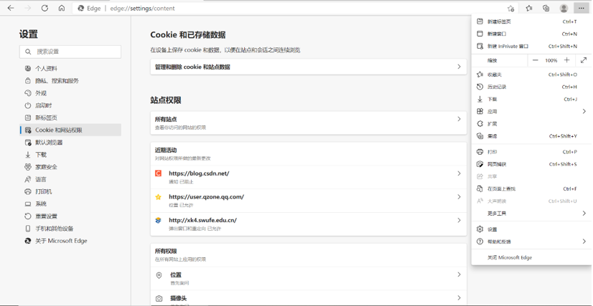

We find and delete the cookies.

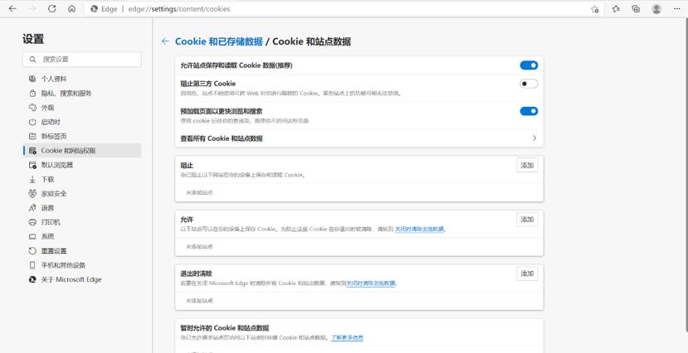

So it will be ”This is a new session”.

